Title (Capitalized)

First name last name (Author 1, presenting),¹ First name last name (Author 2),²..., First name last name (Corresponding author)*

Affiliations: (1) Institution, Street address, postal code, town.

(2) Institution, Street address, postal code, town.

E-mail (corresponding author):

Abstract

Here comes the abstract text, References, if any are inserted in square brackets like this [1]. If you insert Figures, Tables or else, refer to them in brackets like this (Figure 1). The entire abstract, including references must fit on one A4 page. Excess content will be discarded.

Text

For the entire template, simply overwrite the template text, do not change the font etc. Thank you.

Text

Text

Text

Text

Text

Text

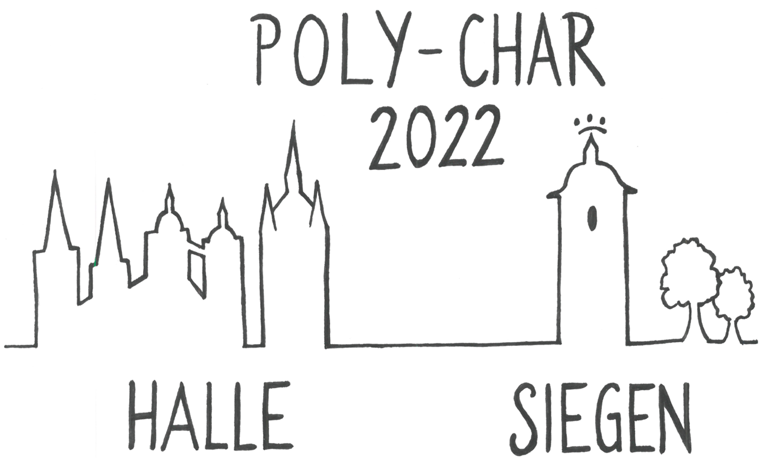

Figure 1. Write a descriptive caption here.

Text

Text

Text

Text

Text

Text

Text

Text

Acknowledgements

Acknowledgements go here.

References

[1] Please use this format: Q. Song, M. Zuo, and H. Schönherr, Langmuir 2019, 35, 7791.

Please fill in the relevant information for abstract submission. By submitting an abstract and the information below, you agree to the following*.

1) Authors
Corresponding author
Presenting author
Title of Submission
Oral preferred
Poster preferred
2) Address & communication
University / Company
Institute
Street address
Postal code
Town
Country
e-mail corresponding author
e-mail presenting author
Time zone (UTC ± x h)
3) Awards presenting authors (tick as appropriate)
Young Scientist (Age at most 37 years before day 1 of conference)
Student (Must be subscribed as student at home University)
4) Remarks

*Disclaimer: 1. After the deadline, all abstracts will be reviewed by the scientific committee of POLY-CHAR 2022 [Halle | Siegen] and you will receive an answer about the acceptance of your contribution.

2. Submission of figures etc. implies that the corresponding authors holds the copyright.

3. By submitting the information with this template to the organizing committee of POLY-CHAR 2022 [Halle | Siegen] you agree that your submitted data and the abstract will be saved and will be used for legitimate work to organize the conference. Necessary information might be passed to scientific committee for a remote review process. Accepted abstracts will be published in the conference book of abstracts.

